Liam Treacy Git Guide Functions Assignment.

### Function 1: Git Add

The function of Git Add is to add something to your working depository, type git add. To complete the function, it will add all files excluding those matching lines with git ignore

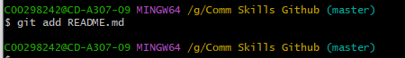

HINT: you do not need to type the second word, type git and press the up-arrow key to quickly access the different functions

## Function 2: Git Commit

The function of Git Commit: this will enter editor mode to enter multiline comment, wil also be the new revision point on the local repository

Type: Git Commit

BEFORE GIT COMMIT –m “first commit”

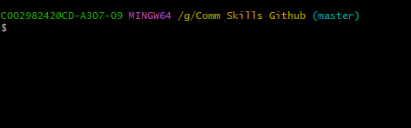

AFTER GIT COMMIT

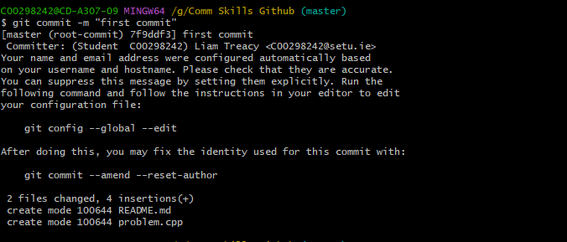

## Function 3: Git Status

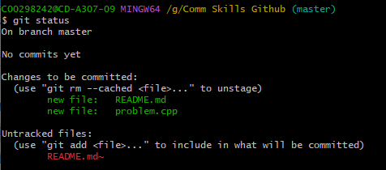

The function of Git Status is to display the information and status of the working depository and all the key information

Type: Git Status

## Function 4. Git Push

Git Push will update the remote node with a current node (node being the origin point) you need to associate with the remote node.

Type: Git Push

## Function 5. Git Init

The function of Git Init is to create a new git repository, it will ignore non code files and the file is specific to each IDE (Integrated Development Environment)

Type: Git Init

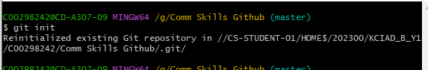

## Function 6. Git Log

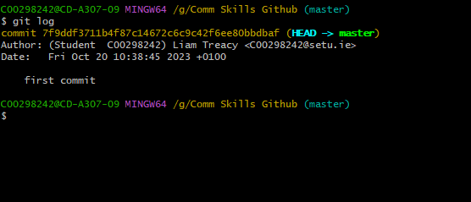

The function of Git Log is to be used after git commit. It will log when it was last committed and by who, as seen above

## Function 7. Git Branch

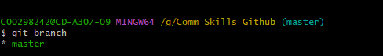

The simple function of Git Branch is to simply list branches in the current remote.

Type: Git Branch

# Function 8: Git Clone

The function of Git Clone is copy of the existing repository in a new location

Type: git clone xxxxxxxxx

Xxxx = url/other relevant info

## Function 9: Git Merge



The function of Git Merge is taking individual git lines of development from a repository and turning them into a separate branch

Type: Git Merge xxxxxxx

## Function 10: Git Stash



Git Stash: The function of Git Stash is to stash lines of code and other files and save them, allowing you to work on something else in the mean time.

Type: Git Stash xxxxxx